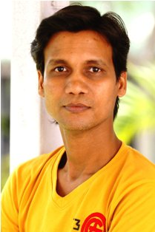

DURGESH KUMAR

Durgesh Kumar born and brought up in Unnao, Uttar Pradesh, is an actor/trainer and director who has been completed his masters in dramatic arts from National School of Drama, New Delhi in 2009, with specialization in Acting. Durgesh has been extensively working in the ﬁeld of theatre since 1992. Durgesh has been associated with various groups and art organizations around the country and participated in more than 90 major plays as an actor. Durgesh travelled through China and South America for various festivals. He has been also acted in Cinema and TV serial. His roles in the French ﬁlm, Alexandra David Neel (2012) and Kafan-Hindi (2004) were well acclaimed and TV serial 12/24 Karol Bagh for ZeeTV. Durgesh received young artists scholarship awarded by the Ministry of Culture in the ﬁeld of Folk theatre: Nautanki in 2001.

